Riesling Cake
Calculated for a springform pan 28cm Ø – 0 pieces
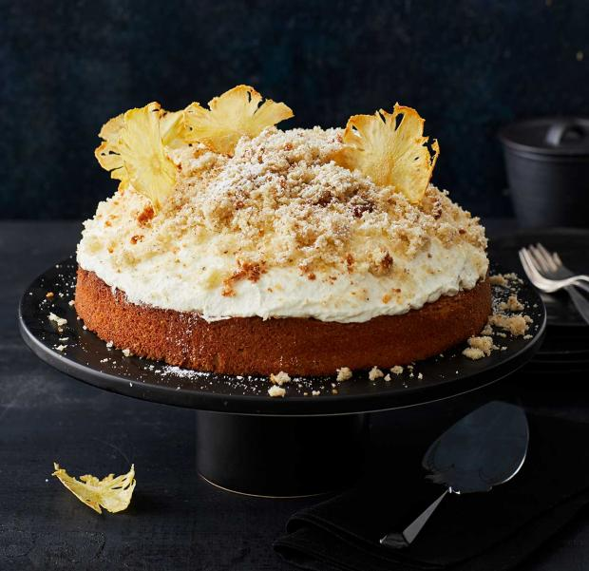
Dough:
125 g almonds peeled
200 g Butter (soft)
200 g flour
180 g sugar
2 tsp Backing powder
1 pk Vanilla sugar
pitch of salt
3 eggs (medium size)
100 ml milk
For the filling:
900 g pear (soft but not to ripe)
20 g fresh ginger
60 g sugar
juice of 1 lime
200 ml Riesling sweet
3 tbsp starch flour
Topping:
500 ml of whipping cream
custard sugar to taste
-----------------------------------------------------------------------------------------------------------------------
Dough:
Finely ground the almonds in a blender. Then roast them at 180°C for approx. 7 min in the oven. Let cool down.
Grease the form with butter or use backing paper.
Mix flour and baking powder. Beat butter, sugar, vanilla sugar and pitch of salt for approx. 5 min until creamy and white. Add the eggs one by one and the milk. Fold in the flour and almonds. Transfer into the form.
Bake for 30 min, middle rack, 175 °C - Let cool completely
Filling: Peel the pears, cutting them into small cubes 1cm x 1 cm. Put them in a bowl with water and lemon juice. Peel and grate the ginger. Heat the sugar and lime juice and let caramelize. Immediately add the pear cubes and ginger plus 100 ml Riesling. Let simmer for 4 min (depends on the softness of the pears). Mix the starch with the remaining Riesling, add to the compote and thicken it.
Let cool completely best overnight.

Assemble the cake:
Use a spoon to hollow out dough 1,5 cm deep – let stand an edge of 3 cm.
Fill the pears into the hole. Cover them with whipped cream creating a dome.
Crumble the dough that was spooned out and sprinkle on the cream. Dust with custard sugar.
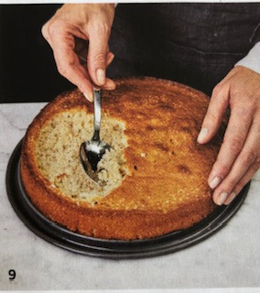
Riesling cupcakes
Use the same dough. Poach the pears but use less starch to thicken them. Let cool in the liquid and then drain in a strainer. Save the Riesling liquid.
Spoon the dough into cupcake cases until half full. Top with a spoon of poached pears and bake for approx.. 15 min / 175 °C
Let cool completely
Buttercreme frosting:
125 ml g unsalted butter, at room temperature
4 cups icing sugar, sifted / use less sugar if you want it to be close to German taste not too sweet
60 ml 35% whipping cream
2 spoons of the Riesling liquid
pinch salt

Prepare the frosting
Beat butter until light and fluffy. With mixer on low speed, beat in icing sugar, cream, Riesling and salt until smooth, adding up to 2 tbsp (30 mL) more cream if needed. According to taste substitute cream with Riesling to give the frosting the Riesling taste. Increase speed to high; beat for 1 to 2 minutes or until frosting is light and fluffy.
Spoon frosting into resealable bag and clip off one corner to pipe over cupcakes.

